**Transient state - homework**

1. Initially, the switch is closed. Determine the current variation i1 and the voltage across the coil 2L.

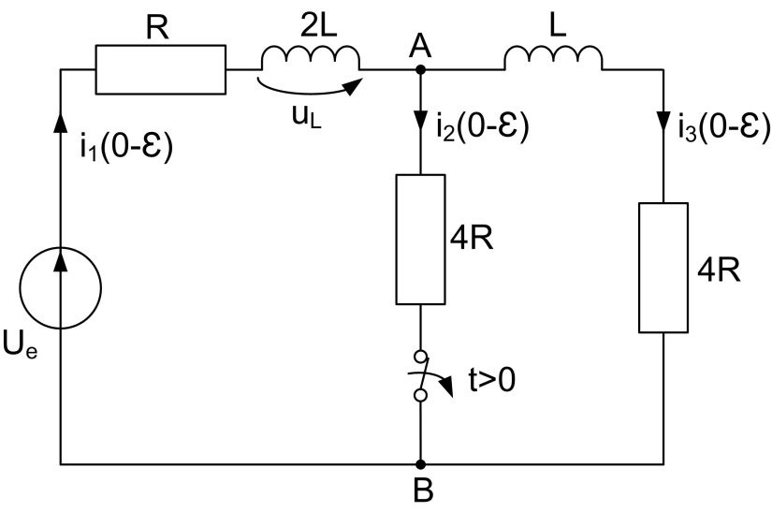

Fig. 1

2. Initially the switch is closed. Determine the current variation i(t) and the voltage across the capacitor uC(t).

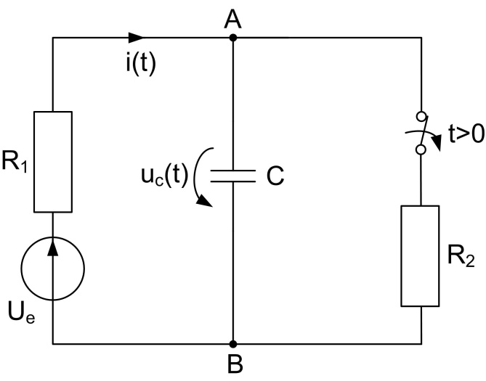

Fig. 2

3. Initially the switch is opened. Determine the current variation i(t) and the voltage variation across the coil uL.

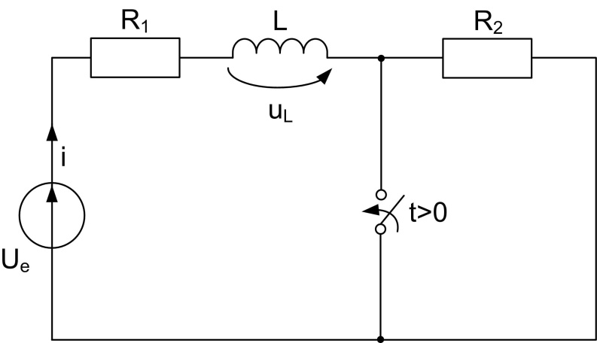

Fig. 3

4. The contact opens at t=0. Determine the variation in time of the current i(t) and the variation of the voltage across the capacitor uC(t). $\text{C}\text{=}\text{10 }\text{m}\text{F; }{\text{U}}_{\text{e}}\text{=}\text{200 V; R}\text{=}\text{10 Ω.}$

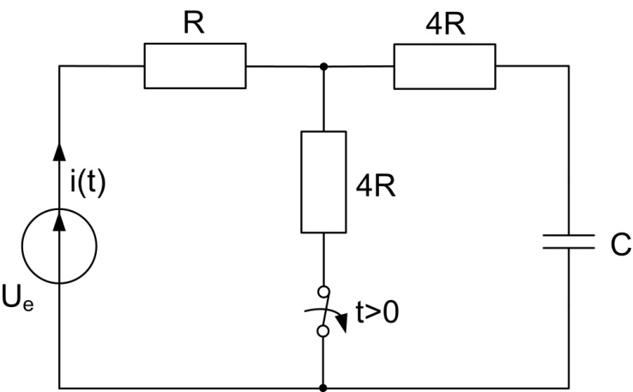

Fig. 4